Dear Sir,

Please find the data, which i was trying to fit using your matlab program. I was able to load data, then circuit path also okay but i would not able to fit it can be please use my data in order to brief me the process of extracting the "s(pRC),p(RC)".

thank you,

regards,

Uv

Put data in vectors :

>> f=[500

600

700

800

900

1000

1500

2000

2500

3000

3500

4000

4500

5000

5500

6000

6500

7000

7500

8000

8500

9000

9500

10000

11000

12000

13000

14000

15000

20000

25000

30000

35000

40000

45000

50000

60000

];

>>

>> Zr=[24.64021119

25.32631771

25.61189399

25.64810067

25.51828769

25.27188915

23.11229821

20.37361926

17.65844448

15.21138201

13.10923312

11.34709733

9.886466658

8.679883011

7.681976813

6.853470813

6.161928134

5.581180971

5.090348566

4.672833172

4.315437345

4.007637672

3.741006628

3.508760018

3.126470475

2.827847829

2.590579559

2.399195809

2.242740771

1.769039647

1.543996165

1.420167742

1.34495624

1.295918913

1.262197448

1.238025766

1.206475074

];

>>

>> Zi=-[4.901475685

2.840501911

1.0665293

0.47768427

1.837479141

3.04603307

7.475750308

10.07993152

11.49470121

12.12463131

12.25665716

12.08779811

11.74735389

11.31719954

10.84775277

10.36926519

9.899328046

9.447693103

9.019312185

8.61623527

8.238789818

7.886310968

7.557591851

7.251159441

6.698865952

6.217165889

5.795052831

5.423159275

5.093688964

3.893092253

3.142149075

2.631147029

2.261875035

1.982909358

1.764889733

1.589886879

1.326522215

];

After putting the data in f, Zr and Zi, put them in one matrix :

data=[f,Zr,-Zi]

Note the minus, I guess you forgot that if your system is capacitive as you suggested in the model RC RC.

Give an eye on the data in simply typing :

Zfit(data)

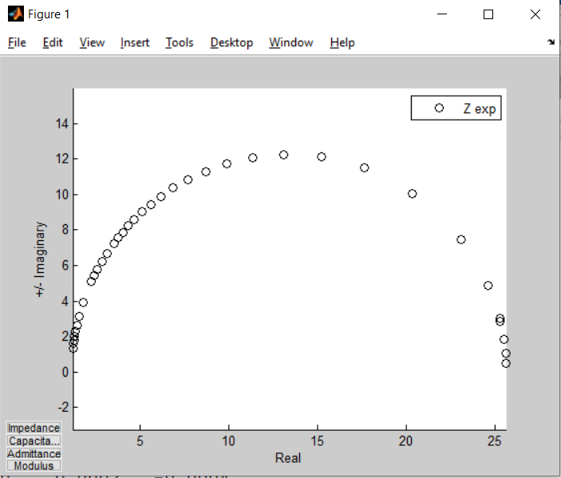One gets the figure :

Note R=25 Ohms

Click on the capacitance button :

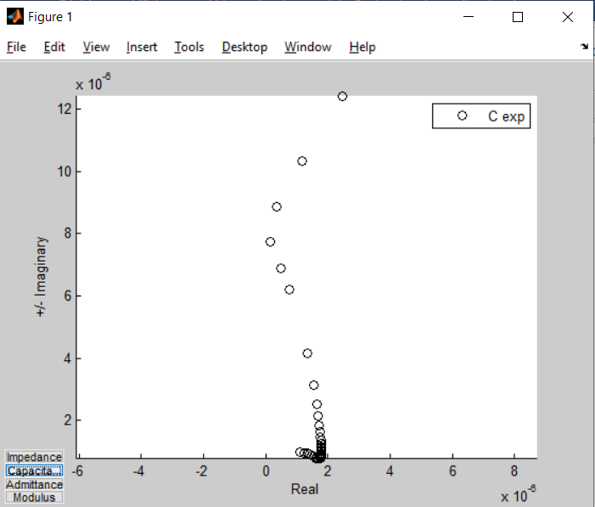

Real part Cr decreasing is not natural according to my knowledge. It could be due to non equilibrium conditions as met in corrosion system or other exotic systems I dont know. Unfortunatly you say nothing about the studied system.

From the HF semi-circle one reads approximatly C=2 10-6 F

Also from BF, we deduce a DC conductive branch which leads me to the model :

'p(s(R1,C1),R1)'

Now lets try :

Zfit(data,'z','p(s(R1,C1),R1)',[1,2e-6,25])

The first R is set small because the semi-circle looks like begin (HF) at almost zéro.

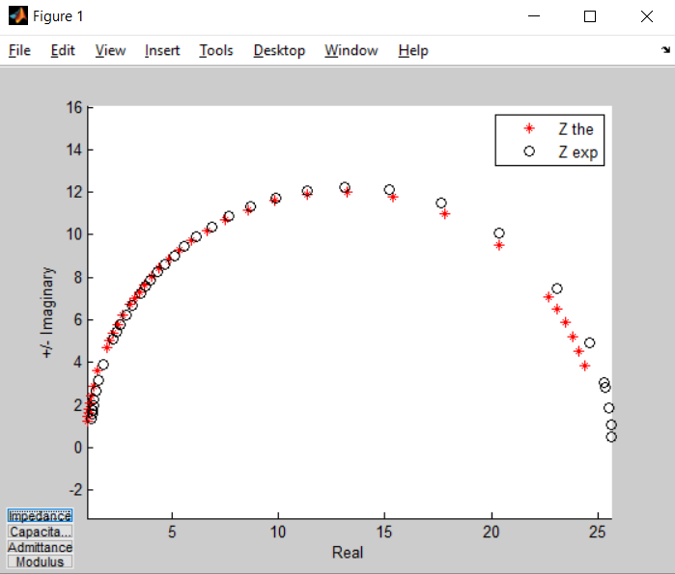

The result is already good enough.

Now final step : the fit :

pbest=Zfit(data,'z','p(s(R1,C1),R1)',[1,2e-6,25],[],'fitNP')

gives :

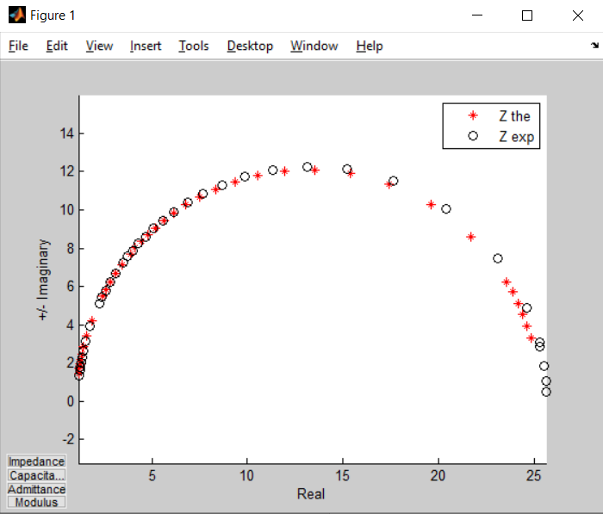

>> format short e

>> pbest

pbest =

1.1426e+00 1.6721e-06 2.5303e+01

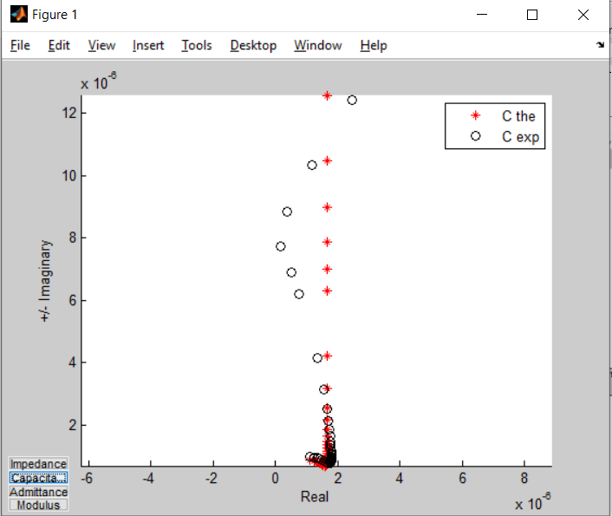

In the capacitance plane, one states that the decreasing Cr cannot be modeled with simple R and C as expected according my knowledge.

All that is explained in the help lines of Zfit, ZfitGUI you must read and understand and in the tutorial accompagning this last program which is shared also in the Matlab web site.

I must however say that I lie in presenting that in a linear manner when, in real I tried the s(p(R,C),p(R,C)) you suggested. However because the program could not converge to a reasonable solution, I had to have a look on the C plane to get the correct model.

I suggest you to work with ZfitGUI and to study the tutorial you may find here :

<https://drive.google.com/drive/folders/1-tA0xR6mjzoTp7F40OcrXGD5IxgHGdl1>

best regards,

Jean-Luc Dellis